Q1) **Write a program to create an application using spring MVC where we can display CRUD operation.**

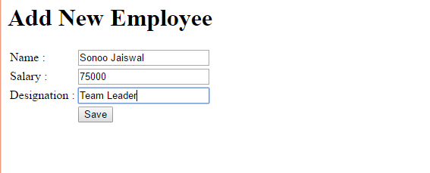

**And display the list where you can edit and delete Employees**

